Introduction
Last holiday season, Amazon Echo became one of the best-selling products in the US. While undoubtedly popular, these devices are only the tip of the ice berg as a large number of AI-powered devices are being introduced every month.
While still immature, we predict that the AI powered ecosystem, Google has also launched a new device, will explode over next six to eighteen months.
In the following tutorial will make walk through creating a custom Alexa skill (i.e. application) to make your Alexa device more useful.
- During this tutorial we will make no assumptions about your programming ability.
- Even if you don’t own an Echo, you can follow along using this well site to simulate using https://echosim.io/.
If you’re a developer, feel free to skip around and jump straight into alexa-app documentation.

How Alexa Works
When you ask Alexa for something, it triggers an Alexa Skills Kit, which is often linked to AWS Lambda to execute the code.
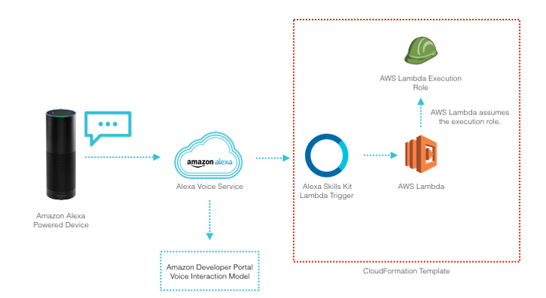

Getting Started
So before we get to write any code, we need to get an Amazon Developer Account and set up our cloud.
Sign in to your existing account

Creating a new free AWS Account
If you already have an AWS account you can skip rest of this section.
- Launch a web browser and navigate to https://aws.amazon.com/
- Select either the “Create an AWS Account” or “Create a Free Account”
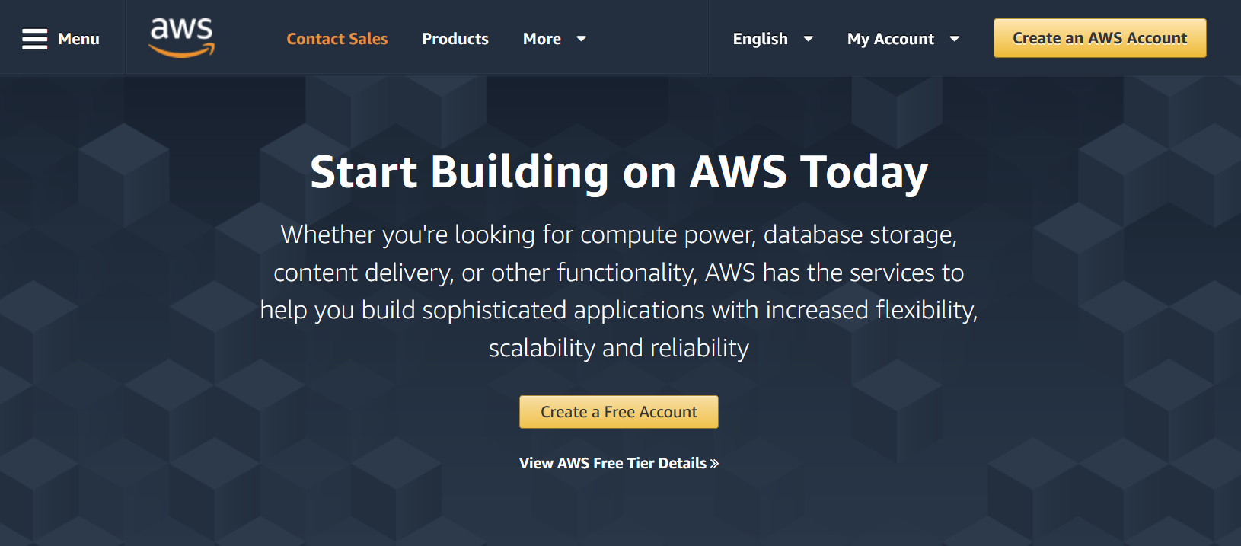
- Enter the following information
  - Email address
  - Password
  - Confirm Password
  - Account Name
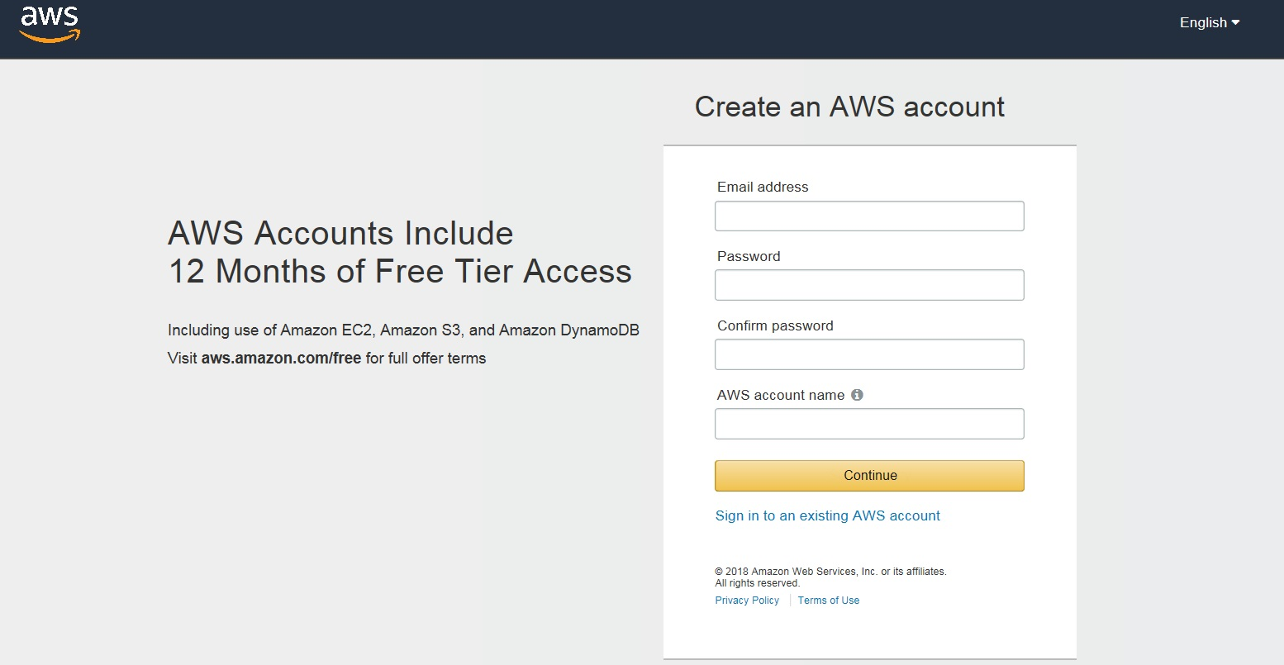
- Note: Creating a new AWS account might take a while

Create a Lambda function:
- Select US East (N. Virginia) region on the top right panel next to Support
- Select Lambda under Compute and click Create a Lambda Function
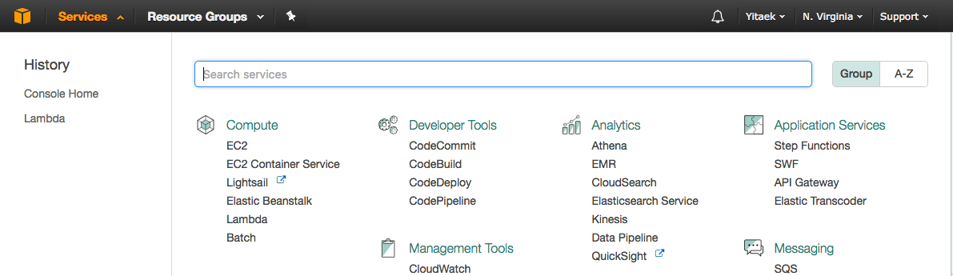
- Under Select Blueprint, search for alexa-skills-kit-color-expert and choose that blueprint.
- We are going to use node.js version
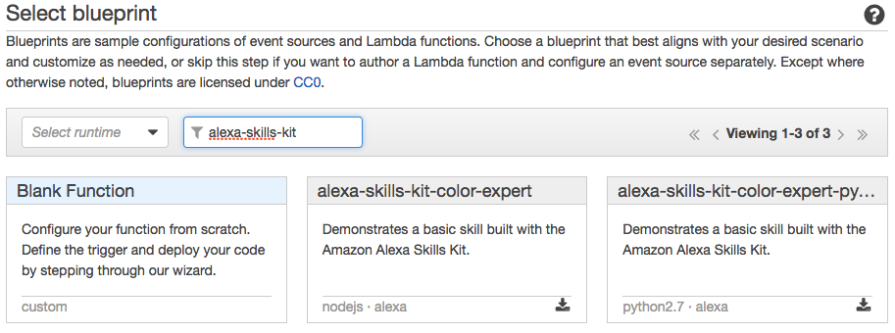

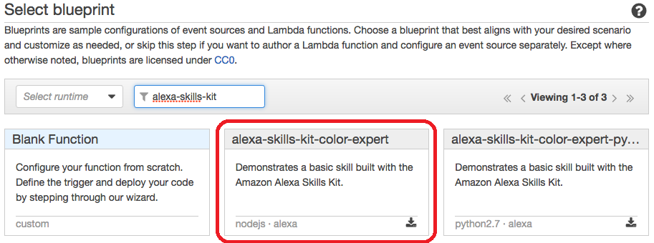
Head over to https://console.aws.amazon.com/lambda/home?region=us-east-1#/create?step=2 to sign in or create an AWS account (as our reader J pointed out):

4. Click next as Configure triggers should already be preset.
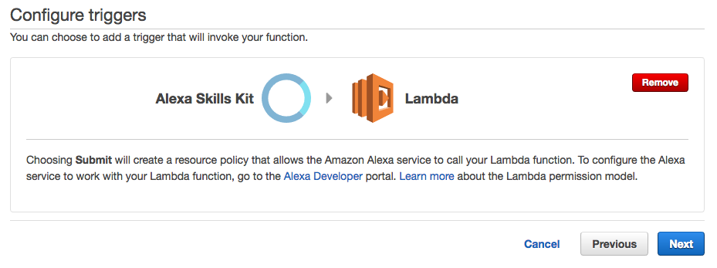
5. Now give your function any name (e.g. myLunchApp)
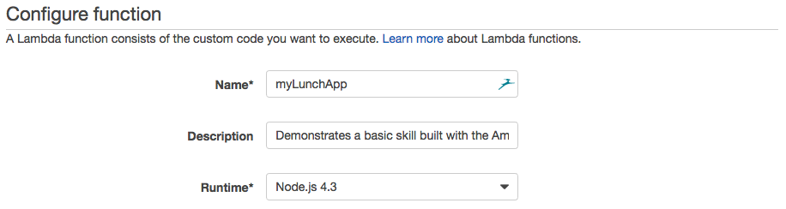
6. Scroll down to Lambda function handler and role. You may already have ‘service-role/BasicExecutionRole’ or you may scroll the dropdown menu to ‘lambda_basic_execution’. If you find none of these options, refer to https://developer.amazon.com/blogs/post/TxDJWS16KUPVKO/new-alexa-skills-kit-template-build-a-trivia-skill-in-under-an-hour for IAM role setup.
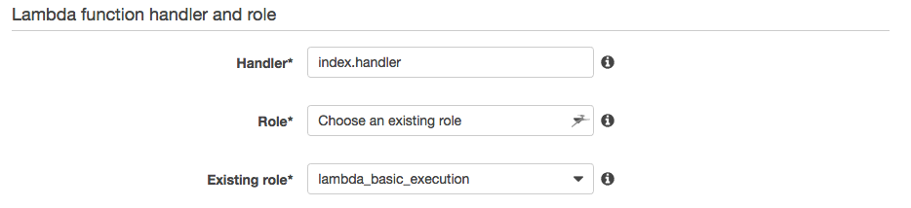
7. Click Next and Create Function to finish the setup!
8. Note the ARN on the top right as we will need this later

Our Alexa Program
With our AWS Lambda instance setup, now it’s time to start programming! This guide assumes no programming experience or setup, so even if you’ve never used terminal, git, or node, you can still follow along!
First, we must download Node.js to start writing our custom app. You can open terminal by doing a spotlight search. Now type the following:
node -v
If it returns something similar to v6.9.1, you already have node.js installed. If not, follow the instructions on https://nodejs.org/en/download/ to download node.js.
Next, we will create a new folder for our project under Documents folder.
cd ~
cd Documents
mkdir AlexaApp
cd AlexaApp
Type those four commands in sequence. In essence, we changed into the Documents folder, created a folder named AlexaApp and switched into the folder.
Now we will initialize our folder. This command will create a file called package.json to store a record of the libraries we use.
npm init -y
We will use a library called alexa-app to help abstract away the underlying magic with Amazon’s Alexa API.
npm install --save alexa-app
Once the install is finished, you should see something like:
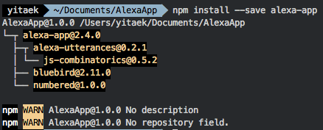
Now we will create a file called index.js and open it in a text-editor:
touch index.js
open index.js
In your text editor, copy the following code and save:
var alexa = require('alexa-app');
var app = new alexa.app();
app.launch(function(request, response){
response.say("Hello there, I am a bot created to help you find what to eat for lunch.");
response.shouldEndSession(false);
})
app.intent('GetLunchSuggestions',
{
"slots": {},
"utterances": [
"what's for lunch",
"where should {I|we} go for lunch"
]
},
function (request, response) {
generate_suggestions(response);
return;
}
);
function generate_suggestions(response){
var food = ["Thai",
"Sushi",
"Chik-fil-a",
"Smash Burgers",
"Uncle Julio's"
];
var rand = food[Math.floor(Math.random() * food.length)];
response.say("How about some " + rand + " today?");
response.send();
return ;
}
// Connect to lambda
exports.handler = app.lambda();
if ((process.argv.length === 3) && (process.argv[2] === 'schema'))
{
console.log (app.schema ());
console.log (app.utterances ());
}
To break down the code, I’ll give a high-level overview of what’s happening in each block:
app.launch provides an introductory message to our user. You can customize anything inside response.say to your own welcome message.
app.intent will be used by AWS Skills Portal to decipher our user’s intent (which is GetLunchSuggestions in this case) and possible things the user might say to ask Alexa for our intent.
generate_suggestions randomly picks a cuisine type under the variable food (which you can customize for your preferences) and outputs a suggestion.
Now type the following in the terminal to generate our intents and utterances:
node index.js schema
It should generate something like:
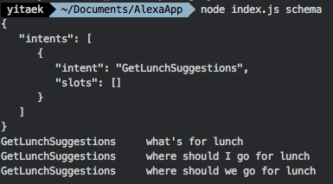
Inside your AlexaApp folder, now create a .zip file compressing all of the files (index.js, package.json, and node_modules). You are now ready for the final step!

Amazon Developer Portal
Go to https://developer.amazon.com/ and sign in with the same Amazon account the Echo is linked to (most likely your default Amazon account).
Click on the Alexa tab and Alexa Skills Kit Get Started button:
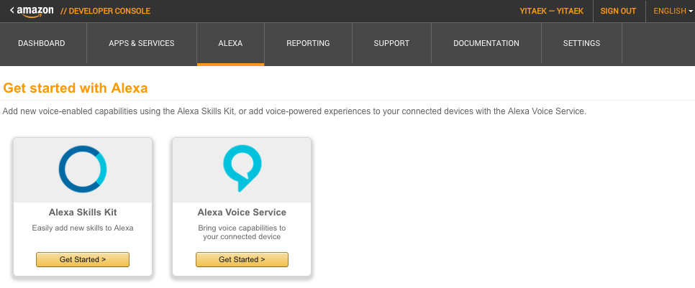
On the top right, click on the yellow box Add a New Skill
Now give the app any name (e.g. MyLunchApp) and an invocation name. This is the phrase you will use to wake up Alexa and use the skill. I called mine Lunch Picker.
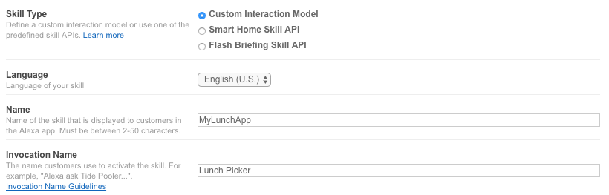
In the Interaction Model, copy and paste the Intent Schema and Sample Utterances generated by our code in the earlier section.
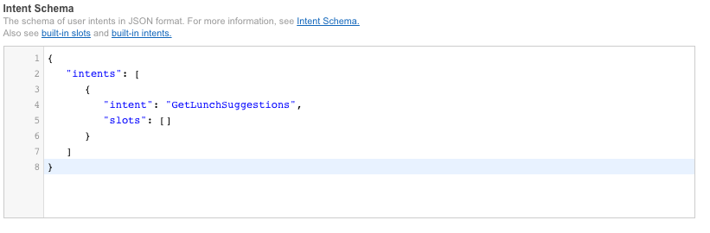
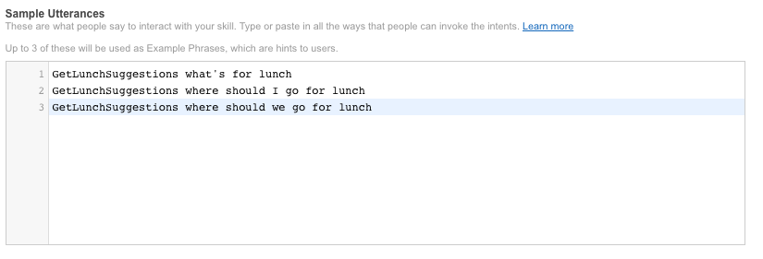
Under Configuration, choose AWS Lambda ARN and North America. In the text box, copy paste the ARN from our AWS Lambda setup that we noted earlier.
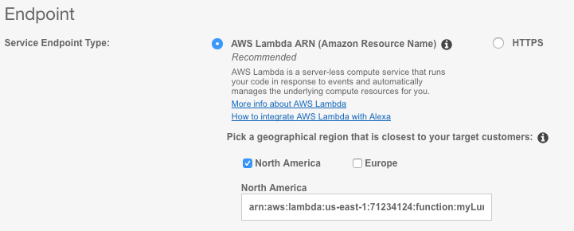
Now let’s switch back to our AWS Lambda tab and locate Code. Then change the Code entry type to Upload a .ZIP file and upload our code.
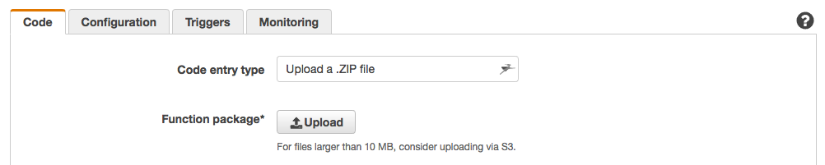
Make sure to hit Save.
Finally, go back to your Amazon Developer Portal and under Service Simulator, type in our sample utterances (e.g. “What’s for lunch”):
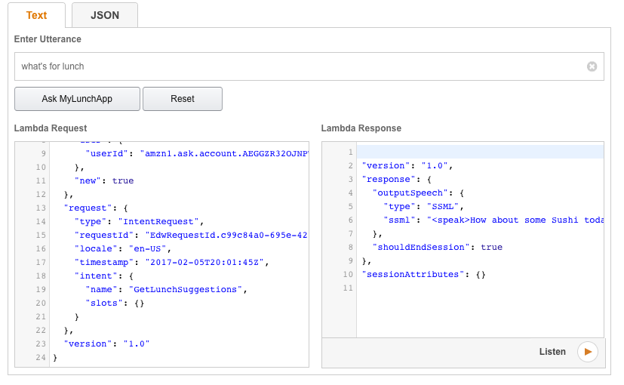
🗓 This article was originally posted on iotforall.com.

Reference:
Yitaek Hwang, “Build Your First Custom Alexa Skill in 10 Minutes”, published Dec 6, 2017, https://medium.com/iotforall/build-your-first-custom-alexa-skill-in-10-minutes-2d27485727ed

